
GALGOTIAS COLLEGE OF ENGINEERING AND TECHNOLOGY
1, Knowledge Park-II, Greater Noida, Uttar Pradesh,201310

FACULTY PROFILE

Name of Faculty | RISHABH KAMAL |  |  |  | 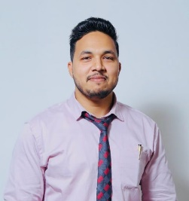
Designation | ASSISTANT PROFESSOR
College and Department | GCET, CSE
Google Scholar ID | https://scholar.google.com/citations?user=mEhyIDUAAAAJ&hl=en
Qualification | UG: BE(IT) |  | PG: MTech.(CSE)
Ph.D (Pursuing) | Specialization: DEEP LEARNING, QUANTUM MACHINE LEARNING, CYBER SECURITY, DATA ANALYTICS
Experience in Years | Teaching: 5.3 | Industry: NA |  | Research:
No. of Papers Published in Journals | National: |  | International: 0
No. of Paper Published in Conferences | National: 3 |  | International: 4
No. of Books/ Books Chapters | Books  published: | Books  edited: |  | Book chapters published: 4
No. of Patents | Published: 1 |  | Granted:
Number of Ph.D./ PG/ UG Guided | Ph.D: NA | PG: NA |  | UG: 12
Details of Professional Membership
Details of Achievements/Awards | - Smart India Hackathon (SIH) final selected team mentor in 2022.  - Artificial Intelligence and Machine Learning Training (Electronics & ICT Academy, Indian Institute of Technology (IIT) Kanpur) – 2021  - Faculty Development Program on Data Science Applications (National Institute of Technology (NIT) Warangal & NIT Raipur) – 2022  - Certified in Python with Machine Learning and Data Structures – 2020–2022  - Cybersecurity Workshop (National Institute of Technology (NIT) Kurukshetra)
Details of Grants fetched
No. of STTPs/ FDPs attended as Resource Person
No. of Conferences/ Seminars/ STCs/ STTPs/ FDPs attended | Conferences: 4 | Seminar: 3 |  | STCs/ STTPs/ FDPs: 10
No. of SWAYAM/ MOOCs attended with certification | 01

