
GALGOTIAS COLLEGE OF ENGINEERING AND TECHNOLOGY
1, Knowledge Park-II, Greater Noida, Uttar Pradesh, 201310
FACULTY PROFILE

Name of Faculty | SACHINDRA PANDEY |  |  |  | 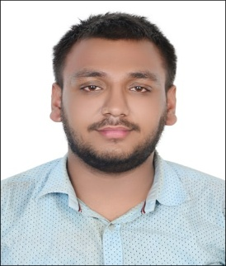
Designation | ASSISTANT PROFESSOR
College and Department | GCET GREATER NOIDA
Google Scholar ID | NIL
Qualification | UG: B.TECH |  | PG: M.TECH
Ph.D (if applicable) | Status: NIL  Specialization: NIL  Title: NIL
Experience in Years | Teaching: 0.1 | Industry: NIL |  | Research: NIL
No. of Papers Published in Journals | National: NIL |  | International: 1
No. of Paper Published in Conferences | National: 1 |  | International: NIL
No. of Books/ Books Chapters | Books published: NIL | Books edited: NIL |  | Book chapters published: NIL
No. of Patents | Published: NIL |  | Granted: NIL
Number of Ph.D./ PG/ UG Guided | Ph.D: NIL | PG: NIL |  | UG: NIL
Details of Professional Membership | NIL
Details of Achievements/Awards | - Qualified GATE
Details of Grants fetched | NIL
No. of STTPs/ FDPs attended as Resource Person | NIL

No. of Conferences/ Seminars/ STCs/ STTPs/ FDPs attended | Conferences: NIL | Seminar: NIL | STCs/ STTPs/ FDPs: NIL
No. of SWAYAM/ MOOCs  attended with certification | NIL

