
GALGOTIAS COLLEGE OF ENGINEERING AND TECHNOLOGY
1, Knowledge Park-II, Greater Noida, Uttar Pradesh, 201310
FACULTY PROFILE

Name of Faculty | PRATEEK PANDEY |  |  |  | 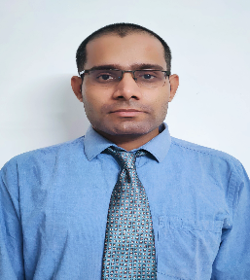
Designation | ASSISTANT PROFESSOR
College and Department | GCET GREATER NOIDA
Google Scholar ID | -
Qualification | UG: B.TECH |  | PG: M.TECH.
Ph.D (if applicable) | Status: Pursuing  Specialization: MACHINE LEARNING  Title: RECIPROCAL RECOMMENDER SYSTEM
Experience in Years | Teaching:1.5 | Industry: |  | Research:
No. of Papers Published in Journals | National: NIL |  | International: NIL
No. of Paper Published in Conferences | National: NIL |  | International: 2
No. of Books/ Books Chapters | Books published: | Books edited: |  | Book chapters published:
No. of Patents | Published: |  | Granted:
Number of Ph.D./ PG/ UG Guided | Ph.D: NIL | PG: NIL |  | UG: NIL
Details of Professional Membership | NIL
Details of Achievements/Awards | - Qualified UGC NET 2019  - Qualified UGC NET 2020
Details of Grants fetched | NIL
No. of STTPs/ FDPs attended as Resource Person | 4

No. of Conferences/ Seminars/ STCs/ STTPs/ FDPs attended | Conferences:02 | Seminar: 1 | STCs/ STTPs/ FDPs: 4
No. of SWAYAM/ MOOCs  attended with certification | NIL

